ECCO PRODUCTS SPECIFICATIONS

ECCOGRAVEL - DESCRIPTION FOR NEUTRAL SPECIFICATIONS

Description of application and materials:
The parking places/fire access roads/ramps/footpaths etc. will be made of HDPE gravel sheets, ensuring a perfectly permeable semi-paved surface that is passable by vehicles and walkable at all times.
The gravel mats manufactured from white/black/grey high density polyethylene will have dimensions of 160x120 cm and a thickness of 3 or 4 cm. They can be folded and will then have handy dimensions of 120x80 cm. The structure consists of honeycomb cells 43 mm in diameter with plastic reinforcements at the top. A 50 g/m² non-woven polyester fabric is thermally attached to the underside of this sheet. This fabric extends on two sides of the sheet to provide overlap during installation. This fabric prevents gravel from getting under the mat and also prevents weeds from growing through. The 4 cm thick gravel mats have a pressure resistance of at least 400 t/m² once filled with gravel. In addition, the mats will need to be weather-resistant. The gravel mats are environmentally neutral. Construction of the foundations and laying of the gravel mats will be carried out according to the manufacturer's instructions for laying.
  - 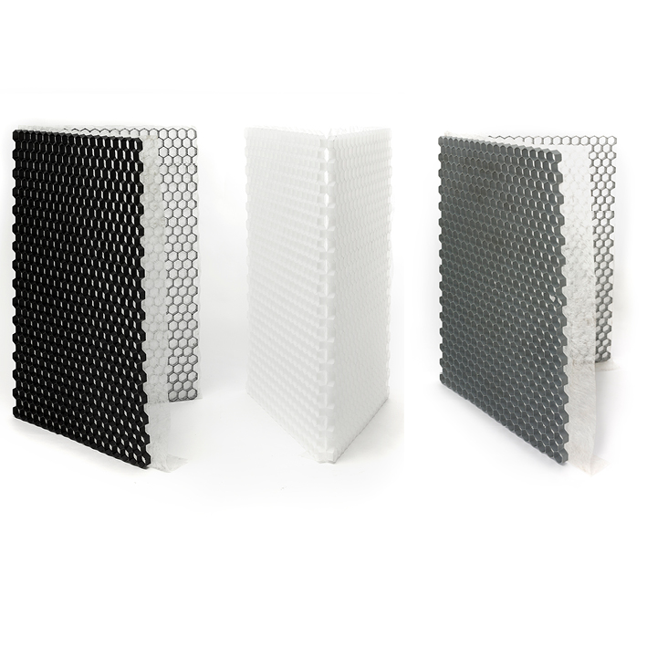

Technical specifications:
FEATURES | SPECIFICATIONS |  | STANDARD
FEATURES | 30 MM | 40 MM | STANDARD
Material | 100% HDPE - high density polyethylene
HDPE density | 0.95 g/cm³
Gravel sheet length | 1600 mm |  | ISO 1923
Gravel sheet width | 1200 mm |  | ISO 1923
Gravel sheet thickness | 30 mm | 40 mm | ISO 1923
Colour | White, grey or black (grey and black = recycled material)
Thermally attached geotextile | Non-woven polyester 50 g/m²
Breaking load when filled | > 300 t/m² | > 400 t/m² | ISO 844
Temperature behaviour | Frost-resistant and UV-resistant
Incline | Inclines up to 15%
Shape retention | -20 °C / +60 °C |  | DIN 53752
Chemical resistance | Resistant to petrol, motor oil, sodium hydroxide, hydrochloric acid
Water buffering capacity of sheet | 4 cm gravel - up to  10 l/m² | 5 cm gravel - up to  8 l/m²

  - Certifications/Tests:
- TÜV certificate
- Climate neutral according to ISO11885/ISO 17294-2A/DIN EN 17933

Laying of gravel sheets
Foundation

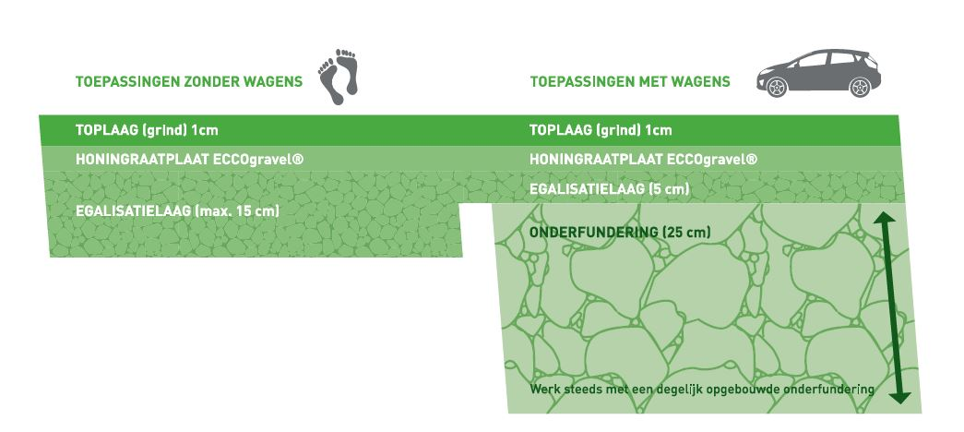
Use without vehicles use with vehicles
Top layer (gravel) 1 cm top layer (gravel) 1 cm
Honeycomb sheet ECCOgravel Honeycomb sheet ECCOgravel
Levelling layer (max. 15 cm) levelling layer (5 cm)
Base course (25 cm)
Always work with a solidly built base course
- Carry out the necessary excavation work. Always remove the topsoil.
- Position the copings/borders. These should extend 2 cm above the level of the top of the gravel sheet.
- Base course: limestone or porphyry chips 0-32 mm or 0-40 mm.
Recommended thickness:
*for parking vehicles: 20 to 30 cm (water buffering capacity 50 to 75 l/m²)
*access roads for fire services: 30 to 50 cm (water buffering capacity 75 to 125 l/m²
- Levelling layer: limestone or porphyry stone chips 2-4 mm or 1-3 mm or screen sand
Recommended thickness:
*vehicles/fire access road: 5 to 10 cm (water buffering capacity 15 to 30 l/m²)
*footpaths/garden paths: 10 to 15 cm (water buffering capacity 30 to 45 l/m²)
N.B. Compact the foundation well between each layer

Laying of the gravel mats
The gravel sheets will be laid in half bond with overlapping geotextile. A sheet can be cut to size with a grinding wheel.
Positioning marking caps
The parking place/ramp/access road etc. will already be demarcated by round marking caps with the following characteristics. The number of marking caps and their arrangement is to be decided in consultation with the architect and the project manager. The marking caps will be placed before the sheets are filled.
Cap diameter | 85 mm
Cover cap diameter | 32 mm
Galvanized frame screw provided TX30 | 7.5x212 mm
Colour | White or black
Material | Polypropylene carbonate (PPC)

Filling the gravel mats
The gravel mats will be filled once the sheets have been laid. When choosing gravel, 4 parameters should be taken into account:
- Particle size:
Particle sizes between 4 and 16 mm are recommended.
Recommended particle sizes for use without vehicles: 4-8 mm
Recommended particle sizes for use with vehicles: 8-16 mm
- Shape
Gravel (round gravel) is recommended for terraces, garden paths, etc. for walking ease.
Gravel (crushed gravel) is recommended for pavements for vehicles. This is because the top layer of gravel will not shift as easily.
- Hardness:
Hard gravel is less likely to crumble under rolling loads and less likely to turn green because of its low porosity. Soft gravel with high porosity, on the other hand, pulverises easily and dissolves over time. This could eventually lead to puddling and rutting. It will also turn green. So a hard gravel type is always recommended.

- Colour:
Gravel or pebble is a natural stone and retains its colour even after a long time.

Maintenance of permeable semi-paving
Depending on traffic intensity and pavement use, sporadic inspection is needed. In places where the honeycomb structure is exposed, it is recommended to cover it again.
Preferably once a year, remove the leaves by raking, blowing or vacuuming them away.
To avoid weed growth, the following will need to be taken into account:
- Choose a gravel type with low porosity. (high porosity= water buffering= more weeds)
- Choose a gravel type with low lime content (high lime content promotes weed growth).
- Make a foundation that does not contain nutrients and drains water readily.
Any remaining weeds (from windblown seed) are counteracted by the non-woven polyester cloth attached to the gravel mat and so can be easily removed by hand. Removal with hot air is also possible.

ECCODAL - DESCRIPTION FOR NEUTRAL SPECIFICATIONS

Description of application and materials:
The green areas/parking places/fire access roads etc. will be made of HDPE (high density polyethylene) sheets that ensure that grassed areas are water-permeable, stable and (sporadically) passable with vehicles.
The grass pavers made of green/black recycled high density polyethylene will have dimensions of 80 x 80 cm and a thickness of 4 or 5 cm. The structure of the grass pavers will consist of 6.9 x 6.9 cm squares and be fitted with internal expansion joints to absorb thermal and mechanical stresses. The grass pavers will be fitted with a click system for attachment. They will have a weight of 3.17 kg/paver (4 cm thickness) or 3.90 kg/paver (5 cm)
The empty grass pavers will have a compressive strength of minimum 50kN/75kN and will withstand atmospheric influences and bad weather. They will be resistant to UV radiation and frost as well as to petrol, hydrochloric acid, motor oil and sodium hydroxide. They will meet the technical specifications below.

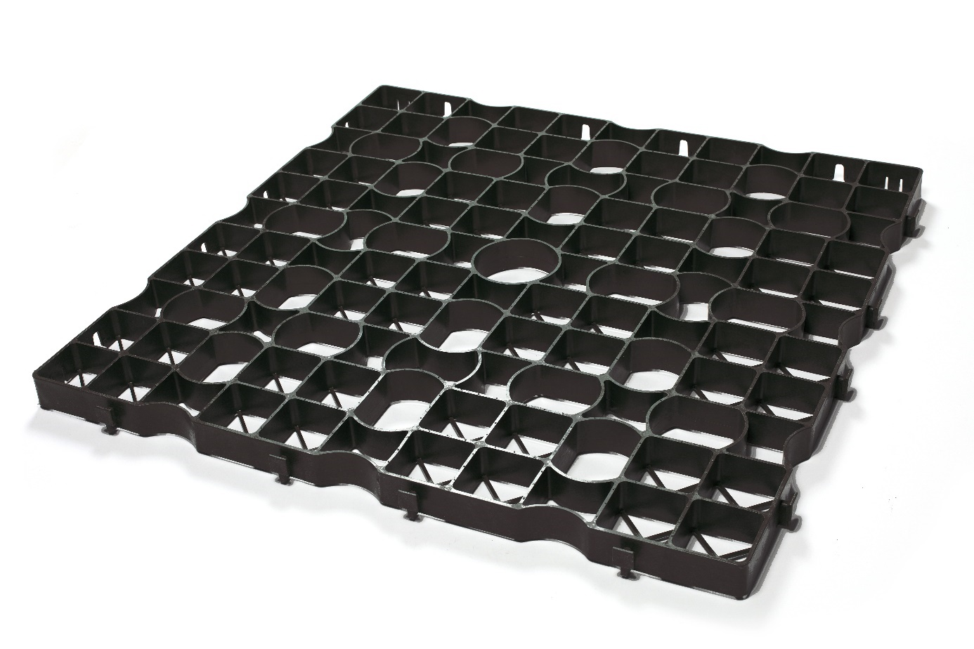

Technical specifications:
FEATURES | SPECIFICATIONS |  | STANDARD
FEATURES | H: 4 CM | H: 5 CM | STANDARD
Composition | 100% HDPE - high density polyethylene
Grass pavers length | 80 cm |  | ISO 1923
Grass pavers width | 80 cm |  | ISO 1923
Grass pavers height | 4 cm | 5 cm | ISO 1923
Weight per paver | 3172 g | 3904 g
Colour | Green or black
Temperature behaviour | Frost-resistant and UV-resistant |  | DIN 4892-3
Chemical resistance | Resistant to petrol, motor oil, sodium hydroxide, hydrochloric acid
PROPERTIES ACCORDING TO PTV828 | SPECIFICATIONS |  | STANDARD
PROPERTIES ACCORDING TO PTV828 | H: 4 CM | H: 5 CM | STANDARD
Compressive strength | Min 50 kN | Min 75 kN | PTV828
Axle load | 100 kN (10 tons) | 100 kN (10 tons) | PTV828
Distortion at 40 kN | Min 2% | Min 2% | PTV828
Connection type | 8 fixed | 8 fixed | PTV828
Tensile joint strength | > 3.0 kN/m | > 1.0 kN/m | PTV828
Use class | B | A | PTV828
  - Certifications/Tests:
- TÜV certificate (no. 18 07 90315 001)

Laying grass pavers
Foundation
- Start with a foundation base course suitable for semi-paving. A mixture based on pure topsoil, green compost and concrete rubble is very suitable for this as it has both a nutrient and a foundation function. Recommended thickness after compacting: 20 to 35 cm, depending on the use.
- Provide substrate for base course. Ideally, this consists of crushed porphyry, green compost and lava, among others. Lay 5 cm of this and roll it in. This provides a surface that is firm and allows the grass to put down roots at the same time.
- Wait 6 to 8 weeks before using the parking place. For intensive use, we recommend waiting 16 weeks.
Laying the grass pavers
Lay the grass pavers and "click" them together. Cutting to size can be done using a grinding wheel.

Positioning marking caps
The green zone/parking places/fire access road etc. will already be demarcated by means of marking caps specifically designed and adapted for the grass pavers and will have the properties below. The marking caps will be fitted with vertical tension ribs that function as barbs, allowing the caps to fully engage with the grass pavers.
The number of marking caps and their arrangement is to be decided in consultation with the architect and the project manager. The marking caps will be placed before the sheets are filled.
Dimensions | 74x74 mm
Colour | White or black
Material | Polypropylene carbonate (PPC)

Filling the grass pavers
- Fill the grass pavers up to 1 cm below the top with a grass paver substrate. This preferably includes pure topsoil, green compost and lava. The substrate must be sufficiently permeable.
- Sow the grass. Choose sturdy types such as red fescue.
- Water the grass parking place, depending on weather conditions, until the grass is well and truly sprouted.
Grass parking place maintenance
Once the driveway or grass parking place has been sown, a period of at least 3 weeks should be allowed before using it for the first time or sporadically. After about 12 to 16 weeks, the grass will have grown sufficiently and will be strong enough.
The maintenance of a grass parking place can be compared to the maintenance of a normal lawn. If you want an attractive green lawn, you will need to mow and fertilise it regularly. Fertilisation can be done quite quickly by spreading some organic manure twice a year (March and September). Additionally, you can lime the lawn in February.
Note: these laying instructions are purely advisory. Each project is unique with the substructure and substrates determined according to use.

ECCODAL HD FLEX 40 - TECHNICAL DATA SHEET

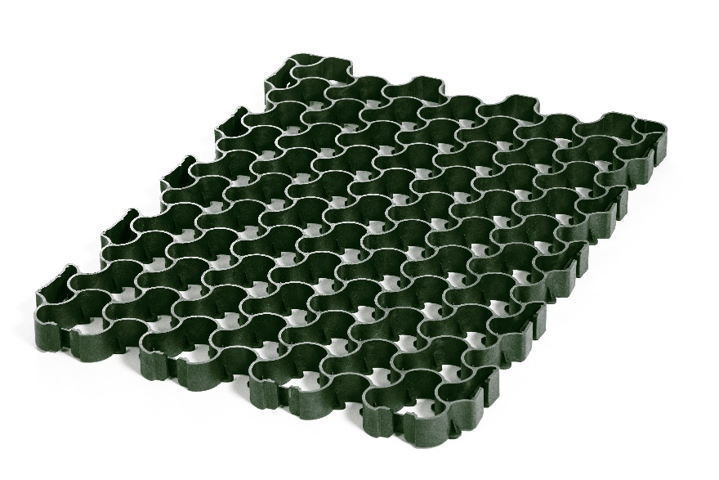

Technical specifications:
FEATURES | SPECIFICATIONS | STANDARD
Composition | 100% recycled and 100% recyclable materials
Grass pavers length | 79.1 cm | ISO 1923
Grass pavers width | 59.2 cm | ISO 1923
Grass pavers height | 4 cm | ISO 1923
Weight per paver | 2412 g/paver
Colour | Green with nuances of grey
Temperature behaviour | Frost-resistant and UV-resistant | DIN 4892-3
Chemical resistance | Resistant to petrol, motor oil, sodium hydroxide, hydrochloric acid
PROPERTIES ACCORDING TO PTV828 | SPECIFICATIONS | STANDARD
Compressive strength | Min. 254 t/m² | PTV828
Axle load | 20 t | PTV828
Distortion at 40 kN | Min 2% | PTV828
Connection type | fixed | PTV828
Use class | A | PTV828

ECCO DRAINBASE - DESCRIPTION FOR NEUTRAL SPECIFICATIONS

Description of application and materials:
The artificial lawn will be placed on black draining tiles made of 100% high density polyethylene (HDPE). The tiles will have dimensions of 60x60 cm (grout included) and a height of 3 cm. The weight per tile will be 687 g. The tiles will be fitted with a unique and patented connection system that allows expansion and contraction of the tile within its own dimensions, when laid in both low and high temperatures. The tile will have a water buffering capacity of 30 litres per m².
The inverted checkerboard pattern that makes up the tiles guarantees good load distribution to the foundation on the one hand and a stable contact surface on the other. The top has an anti-slip layer which makes it difficult for the artificial grass to slip. The sheet is divided into 9 flexible zones to maintain maximum contact with the base course in all conditions.
The system comes with matching green attachment caps that can be clicked into the sheet. These serve as the basis for attaching the artificial grass and the edging profile.
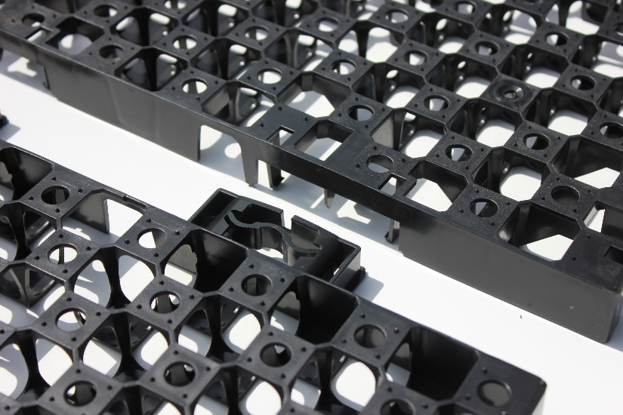

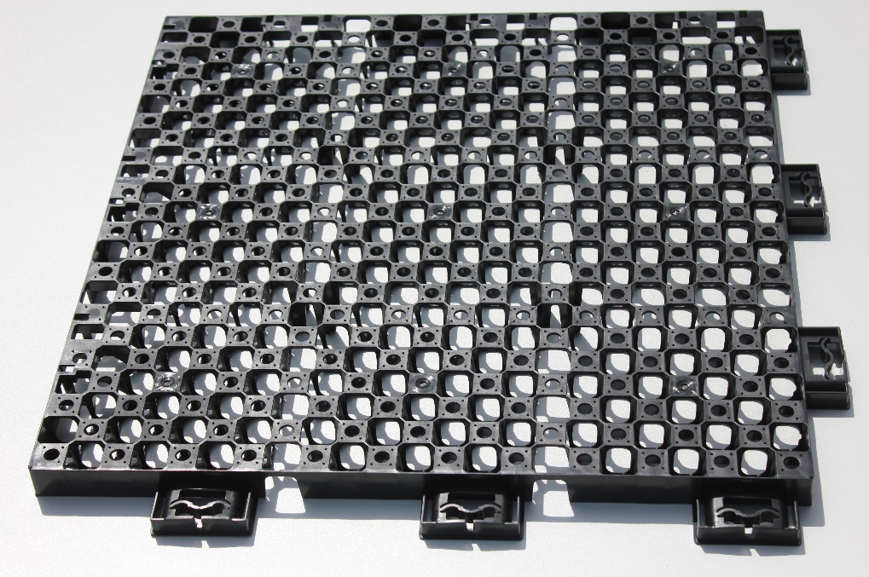

Technical specifications:
FEATURES | SPECIFICATIONS
Composition | 100% HDPE - high density polyethylene
Tile length | 60 cm
Tile width | 60 cm
Tile height | 3 cm
Weight per tile | 687 g/tile
Compressive strength | Min 90 t/m²
Water buffering capacity | 30 l/m²

Laying grass tiles
Foundation for landscaping use
- Place geotextile on top of the existing soil
- Provide a foundation of about 5 cm in crushed stone 0-2 mm, 2-4 mm (20 to 40 litres of water buffering capacity per m²)
- Preferably compact this layer with the roller
Foundation for roof use
- Lay geotextile onto the roof seal
- Place the Drainbase tiles on top
Laying artificial grass foundation tiles
Start with anti-root fabric and place the tiles on top of it. Click the tiles together in the right position. Cutting to size can be done using a grinding wheel. Finish at the sides of the surface with the optional L-profile. This prevents topsoil washing away to the side and prevents pests from getting under the sheets.

Lay the artificial grass on the sheets
Check the places where you wish to attach the artificial grass and insert the green caps there. Secure with the screws provided.
Do not attach the artificial grass to the sides of the lawn yet. First attach the finishing profile provided. You can easily do this by reinserting caps in the sheet at various places. Then position the profile correctly looking through the gaps for the green caps and screwing them into place.
Finally, push the artificial grass under the finishing profile. This prevents the artificial grass from curling up. The inclined profile prevents the grass from sliding back out of the border.
Maintaining your artificial lawn
Although artificial grass requires little maintenance, it is important to take care of it regularly. This will keep your artificial grass attractive for a long time.
These simple tips will help you maintain your artificial grass:
- Brush artificial grass regularly with a hard broom so that it stays nice and straight and leaves, twigs and seeds are removed. If these leaves, twigs and seeds are left lying around, weeds can develop. It is also important to brush artificial grass at least once a year because it can become flatter with use.
- Any stains from pets or drinks, for example, can easily be scrubbed away with water or soapy water.
- We install stabilisation fabric under the support structure. This stops weeds from putting down roots. Should you unexpectedly find weeds in the artificial grass, you can easily remove them by hand. You can also use a hard broom, rake or brush for this.

ECCOSEDUM - DESCRIPTION FOR NEUTRAL SPECIFICATIONS

Description of application and materials:
The green roof/sedum roof/flat roof/sloping roof etc. will be installed with fully pre-cultivated ready-made green roof trays.
Lateral anchoring: The trays have been fitted with recesses and protrusions on the sides to prevent them from shifting in relation to each other.
Vertical anchoring: Two lips per tray ensure that the trays are all attached to each other and cannot be blown up by the wind. Each tray locks over the side of 2 adjacent trays and is in turn held by 2 other trays.
The trays feature vertical cut-outs and emergency spillways so that rainwater not absorbed by the green roof system can drain easily.
The tray can be used on flat and gently sloping roofs with a pitch of up to 25 degrees. For use on larger slopes or over lengths longer than 20 metres, a structure will be needed to limit tensile forces. The advantage of the tray system on sloping roofs is that it is a compartmentalised system; each tray receives the same amount of water so the vegetation is consistent.
The tray is made up of a drainage layer, a substrate layer with significant water buffering capacity and a vegetation layer.
The buffer volume of the sedum trays in combination with the protective layer is at least 35 litres/m²
  - Drainage layer:
The structure of the trays is designed in such a way that rainwater that cannot be retained by the green roof system can run off easily to the drainage points without being blocked.
The lower drain holes are located 1 cm from the bottom so that even non-capillary water can be stored to a limited extent.
  - Substrate layer - water buffering layer:
The cassettes are filled completely (8 cm) with substrate. In some places (near the emergency spillways), the thickness of the substrate is 3.5 cm. The minimum thickness of the substrate is thus 3.5 cm – the average thickness is 6 cm.
The substrate layer has several functions. It provides nutrients and water to the vegetation, as well as oxygen and anchoring for the roots.
ECCOsedum uses a roof garden substrate made up of lava, pumice and green compost for this purpose.
Volume of water buffering per tray: 32.5 litres/m²
Grain size: 0-12 mm
Volume weight of substrate after compaction in dry state: 0.78 g/cm³
Volume weight of substrate after compaction at maximum water capacity: 1.27 g/cm³
  - Vegetation layer:
The pre-cultivated extensive green roof system comes with at least 7 species of sedum plants per m². The cassettes are delivered at least 80% grown over.

Technical specifications ECCOsedum:
FEATURES | SPECIFICATIONS
Composition of tray | 100% recycled and 100% recyclable PP
Tray dimensions | 49 x 45.5 cm
Tray height | 8 cm
Dry weight | 11.7 kg/tray - 51.5 kg/m²*
Saturated weight | 19 kg/tray - 84 kg/m²*
Number of trays per m² | 4.4 units
Water buffering capacity | 32.5 litres/m²
Total volume of substrate per tray | 15 litres*
  - *These are theoretical values. In practice, this may vary slightly because the trays may expand when filled with substrate.

Installation of sedum trays
  - Installation of a root protection layer
Anti-root foil does not always have be used with EPDM or PVC unless specifically requested by the manufacturer.
  - Installing the protective layer
A protective coating is recommended at all times. This is to prevent damage to the roof waterproofing during installation + because of the extra water buffering volume.
PROTECT fabric technical data:
Material: Inorganic felt cloth
Weight: 300 g/m²
Height: approx. 5 mm
Standard roll width: 2.00 m
Water buffering capacity: 3-4 l/m²
  - Installation of the sedum trays
The trays are held together by a click system and are cut using a saw or grinding wheel. The cut side is best placed against the previous tray to reduce the risk of drying out.
Any edge areas can be filled with roof gravel.
Maintaining your sedum roof
Although a DIY green roof is low maintenance, an inspection twice a year is nevertheless recommended.
The green roof can be walked on for maintenance, but is not for regular use as a roof terrace. For this, tiles of wood or concrete are needed.
The following work is required:
- Removal of unwanted weeds and tree seedlings (twice a year)
- Fertilise with the specially formulated fertiliser (once a year, 30 g/m²)
- Removal of weeds from gravel edges
- Cleaning the rainwater drain

MULTIDAL - Description for neutral specifications

Description of application and materials:
The parking place/fire access road/ramp etc. will be made of a frost-resistant HDPE gravel/grass paver with high compressive strength for intensive and frequent traffic and will provide a water-permeable semi-paved surface that is perfectly passable by vehicles and walkable at all times.
The gravel/grass sheets made of black or white high density polyethylene will have dimensions of 113.2 x 78.3 cm – corresponding to 0.89 m² per sheet – and will have a height of 3 cm. The sheets have a closed underside with infiltration openings. This promotes stability while making the sheet highly water permeable. When empty, the sheets have a breaking load of more than 300t/m² and are designed for both gravel and grass filling. Construction of the foundations and laying shall be carried out according to the manufacturer's instructions for laying, depending on whether filled with gravel or grass.
The sheets are resistant to weathering and are neutral to the environment.

Technical specifications:
FEATURES | SPECIFICATIONS
FEATURES | 30 MM
Material white | 100% HDPE - high density polyethylene
Material black | 100% recycled HDPE
HDPE density | 0.95 g/cm³
Gravel sheet length | 1132 mm
Gravel sheet width | 783 mm
Gravel sheet thickness | 30 mm
Colour | Black or white  (black = recycled material)
Breaking load when empty | >300 t/m²
Temperature behaviour | Frost-resistant and UV-resistant
Incline | Inclines up to 15%
Shape retention | -20 °C / +60 °C
Chemical resistance | Resistant to petrol, motor oil, sodium hydroxide, hydrochloric acid

Certifications/Tests:
TÜV certificate (on request)
Climate neutral according to ISO11885/ISO 17294-2A/DIN EN 17933

Installation with gravel
Construction of the foundations and laying shall be carried out according to the manufacturer's instructions for laying.
- Excavation work
Carry out the necessary excavation work. Always remove topsoil down to bearing layer. The load-bearing capacity of this layer should be at least 20 Mpa.
- Installing the edges
Position the edges. These should extend 2 cm above the top of the sheet.
- Installing the foundation box
Install the foundation box/base course at least 25 cm deep. Work in layers of 20 cm at most and compact with a vibration plate. You can for example fill the foundation box with: crushed limestone, crushed porphyry or crushed concrete rubble (crushed stone grain size: 0-32 mm or 0-40 mm). Brick rubble is not recommended for the foundation box, as it pulverises over time.
- Laying the levelling layer
Lay the levelling layer in fine gravel, vibrate and level. Depth of levelling layer in uses for vehicles is 5 cm, in uses without vehicles it is 15 cm. The levelling layer can be done with limestone or porphyry (grain size: 2-4 mm,
1-3 mm or 0-4 mm) or with screen sand.
- Laying the gravel sheets
  - Lay the first sheet parallel to the edge.
  - The next sheet can be connected easily with the new coupling system. It can also be disconnected again, if necessary.
  - We recommend laying the sheets in half bond. Then start the second row with half a sheet, the sheets are easy to cut with a grinding wheel.
  - You start the third row again with a full sheet. Repeat the previous steps and finish the entire surface in this way

- Filling with gravel
The paving is filled once the sheets have been fully laid. When choosing gravel, 4 parameters should be taken into account:
- Particle size:
Particle sizes between 4 and 25 mm are recommended.
Recommended particle sizes for use without vehicles: 4-8 mm
Recommended particle sizes for use with vehicles: 8-16 mm
Maximum recommended particle size: up to 25 mm
- Shape
Gravel (round gravel) is recommended for terraces, garden paths, etc. for walking ease. Gravel (crushed gravel) is recommended for pavements for vehicles. This is because the top layer of gravel will not shift as easily.
- Hardness:
Hard gravel is less likely to crumble under rolling loads and less likely to turn green because of its low porosity. Soft gravel with high porosity, on the other hand, pulverises easily and dissolves over time. This could eventually lead to puddling and rutting. It will also turn green. So a hard gravel type is always recommended.

- Colour:
Gravel or pebble is a natural stone and retains its colour even after a long time.

Lay the gravel. Level with a shovel, brush, rake and squeegee. Do not compact the decorative gravel. Allow the gravel to protrude 1 to 2 cm (1 cm for finer gravel and 2 cm for coarser gravel) above the sheets. The gravel will settle slightly with natural compaction. In time, there should be just enough gravel to make the gravel sheet invisible.

Maintenance of permeable semi-paving filled with gravel
Depending on traffic intensity and pavement use, sporadic inspection is needed. In places where the sheet structure is exposed, it is advisable to cover it again.
Preferably once a year, remove the leaves by raking, blowing or vacuuming them away.
To avoid weed growth, the following will need to be taken into account:
- Choose a gravel type with low porosity.
(high porosity = water buffering = more weeds)
- Choose a gravel type with a low lime content
(high lime content promotes weed growth)
- Make a foundation that does not contain nutrients and drains water readily.

Installation with grass
Construction of the foundations and laying shall be carried out according to the manufacturer's instructions for laying.
- Excavation work
Carry out the necessary excavation work. Always remove topsoil down to bearing layer. The load-bearing capacity of this layer should be at least 20 Mpa.

- Installing the edges
Position the edges. These should extend 2 cm above the top of the sheet.

- Laying the foundation
Start with a foundation base course suitable for semi-paving. A mixture based on pure soil, green compost and concrete rubble is very suitable for this purpose as it has both a nutrient and a foundation function. Recommended thickness after compacting is 20 to 35 cm, depending on the application.
- Laying the substrate levelling layer
Provide a bedding substrate. Ideally, this consists of crushed porphyry, green compost and lava, among others. Lay 5 cm and roll it in for a firm surface that will allow roots.

- Laying the grass sheets
  - Lay the first sheet parallel to the edge.
  - The next sheet can be connected easily with the coupling system. It can also be disconnected again, if necessary.
  - We recommend laying the sheets in half bond. Then start the second row with half a sheet, the sheets are easy to cut with a grinding wheel.
  - You start the third row again with a full sheet. Repeat the previous steps and finish the entire surface in this way.

- Laying the substrate
Fill the grass pavers up to 0.5 cm below the edge with a grass paver substrate. The substrate preferably contains pure topsoil, green compost and lava among other things. The substrate should certainly be adequately water permeable.

- Sowing
Finally, sow the grass. Choose grass types with sturdy leaves such as the red fescue. Water the grass parking place, depending on weather conditions, until the grass is well and truly sprouted. Inspect a few weeks after first use and brush out if necessary.

Grass parking place maintenance
Once the driveway or grass parking place has been sown, a period of at least 3 weeks should be allowed before using it for the first time or sporadically. After about 12 to 16 weeks, the grass will have grown sufficiently and will be strong enough. The maintenance of a grass parking place can be compared to the maintenance of a normal lawn. If you want an attractive green lawn, you will need to mow and fertilise it regularly. Fertilisation can be done quite quickly by spreading some organic manure twice a year (March and September). Additionally, you can lime the lawn in February.

Note: these laying instructions are purely advisory. Each project is unique with the substructure and substrates determined according to use.

